CANTOS

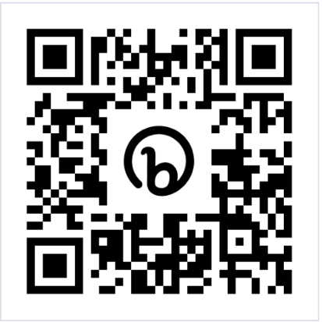
Jesuit’s very own student literary-art magazine Cantos is now accepting submissions! Submit your original artwork, photography, poetry, short stories or creative writing to Cantos by Monday, March 6th

SUBMISSION INSTRUCTIONS:
- Submit all work to bit.ly/CantosJHS
- Images should be uploaded as JPG files
- The file name should be the title of your work and should NOT include your name (for example, "Pink Sunset.jpg")
- Writing should be uploaded as .docx or PDF files. (Do NOT include your name anywhere on the document)
- Limit of submissions per student: SIX
- Email, Ms. Chi at dchi@jesuitportland.org with questions
- You will be notified via email the by April 12th if your work has been selected for publication.

